|  |  |
| --- | --- |
|  | LAB 6: Understanding of DHCP using wireshark and packet tracer. |
|  |  |
|  | Akshar Panchani ID- 202101522  IT304 Computer Networks  10/3/23 |



**Exercise:**

**2.0:**

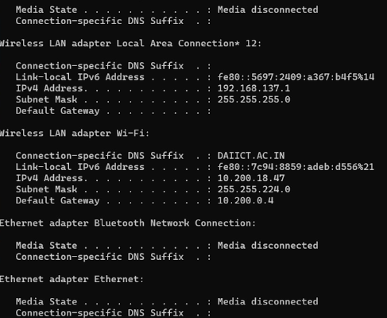

1. Are DHCP messages sent over UDP or TCP?

UDP as below:

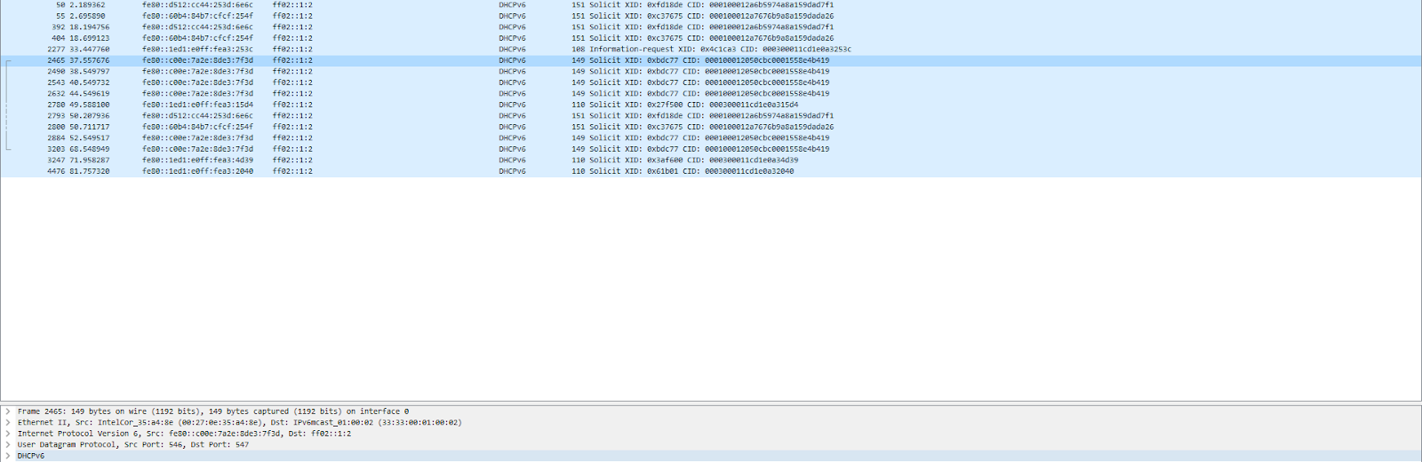

2. Draw a timing datagram illustrating the sequence of the first four-packet Discover/Offer/Request/ACK DHCP ex-change between the client and server. For each packet, indicated the source and destination port numbers. Are the port numbers the same as in the example given in this lab assignment?

DHCP works on port 67 client and 68 server.

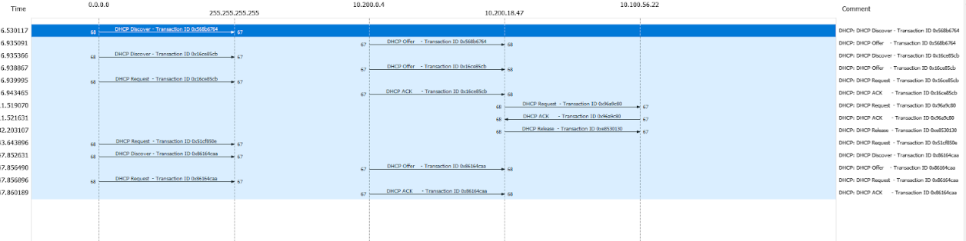

3. What is the link-layer (e.g., Ethernet) address of your host?

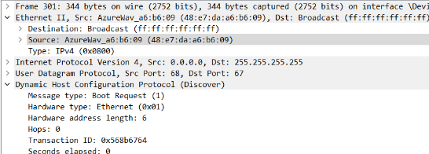

4. What values in the DHCP discover message differentiate this message from the DHCP request message?

It is the message type which differentiates.

5. What is the value of the Transaction-ID in each of the first four (Discover/Offer/Request/ACK) DHCP messages? What are the values of the Transaction-ID in the second set (Request/ACK) set of DHCP messages? What is the purpose of the Transaction-ID field?

The IDs are as follows : 0x568b6764, 0x568b6764, 0x16ce85cb, 0x16ce85cb

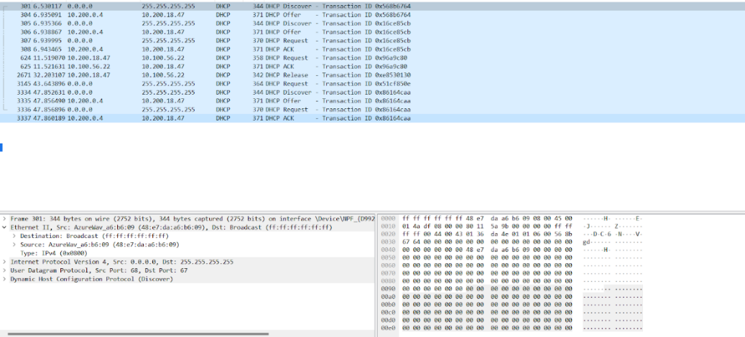

6. A host uses DHCP to obtain an IP address, among other things. But a host’s IP address is not confirmed until the end of the four-message exchange! If the IP address is not set until the end of the four-message exchange, then what values are used in the IP datagrams in the four-message exchange? For each of the four DHCP messages (Discover/Offer/Request/ACK DHCP), indicate the source and destination IP addresses that are carried in the encapsulating IP datagram.

|  |  |  |
| --- | --- | --- |
| Message | Source | Destination |
| Discover | 0.0.0.0 | 255.255.255.255 |
| Offer | 10.196.0.4 | 10.201.19.45 |
| Request | 0.0.0.0 | 255.255.255.255 |
| ACK | 10.196.0.4 | 10.201.19.45 |

7. What is the IP address of your DHCP server?

The IP is 10.196.0.4

8. What IP address is the DHCP server offering to your host in the DHCP Offer message? Indicate which DHCP message contains the offered DHCP address.

The IP of most DHCP is 10.201.19.45

9. In the example screenshot in this assignment, there is no relay agent between the host and the DHCP server. What values in the trace indicate the absence of a relay agent? Is there a relay agent in your experiment? If so what is the IP address of the agent?

Relay agent IP address is 0.0.0.0. This indicates there is no relay agent and hence

there isn't any IP address associated with it.

10. Explain the purpose of the router and subnet mask lines in the DHCP offer message.

We can know where the client should send messages by default by the router line. The subnet mask that will be used by the client and can be determined by the subnet mask lines.

11. In the example screenshots in this assignment, the host requests the offered IP address in the DHCP Request message. What happens in your own experiment?

Once the offer message is received by the host , it sends the request message

again.

12. Explain the purpose of the lease time. How long is the lease time in your experiment?

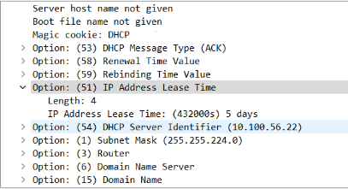

Lease time is the amount of time allowed to the host to use the given address.

Here it is 432000 s => 5 days.

13. What is the purpose of the DHCP release message? Does the DHCP server issue an acknowledgment of receipt of the client’s DHCP request? What would happen if the client’s DHCP release message is lost?

The DHCP release message's objective is to release the IP address to the server so that the server can allocate it to further hosts. No, the client's DHCP request is not acknowledged by the DHCP server after it is sent.

14. Clear the bootp filter from your Wireshark window. Were any ARP packets sent or received during the DHCP packet-exchange period? If so, explain the purpose of those ARP packets.

Yes, during the DHCP packet-exchange time, ARP packets were transmitted and received. These packets were created to provide information about MAC and IP addresses.

**3: Implementing DHCP server in a router**

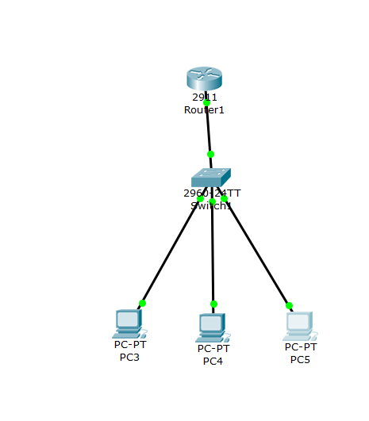

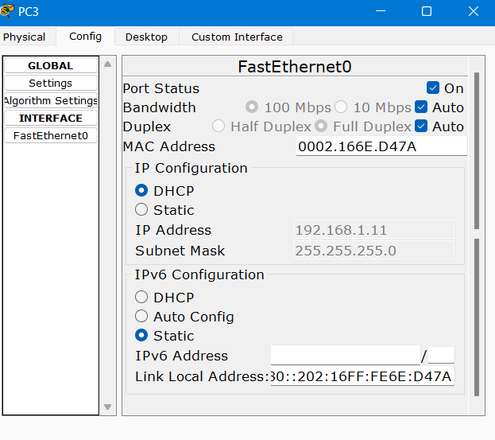

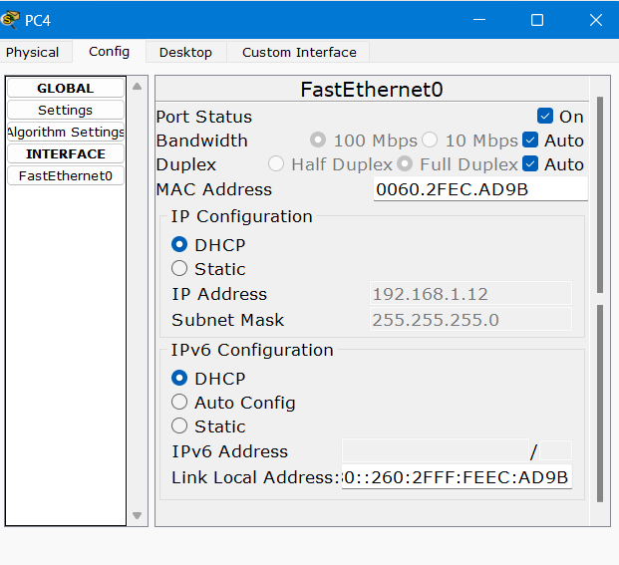

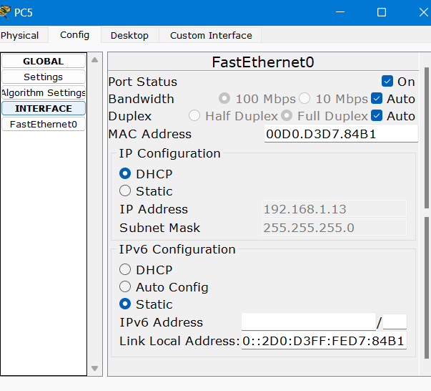

|  |  |
| --- | --- |
| PC | IP |
| 3 | 192.168.1.11 |
| 4 | 192.168.1.12 |
| 5 | 192.168.1.13 |